Batch: A2 Roll No.: 16010122034

Experiment / assignment / tutorial No. 04
Grade: AA / AB / BB / BC / CC / CD /DD

Signature of the Staff In-charge with date

TITLE :An Array of Objects

AIM: Write a program which accepts information about n no of customers from user .Create an array of objects to store account_id ,name,balance.
Your program should provide following functionalities
- To add account
- To delete any account detail
- To display account details.
_____________________________________________________________________
Expected OUTCOME of Experiment:

CO1: Understand the features of object oriented programming compared with procedural approach with C++ and Java
CO2: Explore arrays, vectors, classes and objects in C++ and Java.
______________________________________________________________________
Books/ Journals/ Websites referred:

- Ralph Bravaco , Shai Simoson , “Java Programing From the Group Up” Tata McGraw-Hill.
- Grady Booch, Object Oriented Analysis and Design .
_____________________________________________________________________
Pre Lab/ Prior Concepts:

Arrays of Objects:
Unlike traditional array which store values like string, integer, boolean, etc. array of objects stores objects. The array elements store the location of reference variables of the object.

For example:

class Student {
int rno;
String name;
float avg;
}
Student(int r, String name, float average)
{
rno=r;
this.name=name;
avg=average;
}
Student studentArray[] = new Student[n];

- The above statement creates the array which can hold references to n number of Student objects. It doesn't create the Student objects themselves. They have to be created separately using the constructor of the Student class. The studentArray contains n number of memory spaces in which the address of n Student objects may be stored.
for ( int i=0; i<studentArray.length; i++) {
studentArray[i]=new Student(r,name,average);
}

- The above for loop creates n Student objects and assigns their reference to the array elements. Now, a statement like the following would be valid.
studentArray[i].r=1001;
.
Class Diagram:
Customer
account_id:int
name:String
balance:String
add_account(Scanner sc):Customer
delete_account(Customer[] customers, int index, int len):Customer[]
display_accounts(Customer[] customers, int len)

Algorithm:
- Input number of customer records.
- Create customer records by taking the id, name and balance of accounts from the user.
- Take input action to do:
  - Add account: Check if there is space to add another record. If there is space then take input of id, name, balance of account and add account. Jump back to Step 3.
  - Delete account: Check if there is at least one account to delete. Delete account specified by user. Jump back to Step 3.
  - Display accounts: Display all the records of stored records. Jump back to Step 3.
  - Exit Program
Implementation details:
import java.util.Scanner;
class Customer{
int account_id;
String name;
int balance;
Customer(int id, String name, int balance){
account_id = id;
this.name = name;
this.balance = balance;
}
static Customer add_account(Scanner sc){
System.out.println("\n\n###\n\nEnter the account ID of the Customer: ");
int id = sc.nextInt();

System.out.println("Enter the name of the customer: ");
String name = sc.next();

System.out.println("Enter the balance of the account: ");
int balance = sc.nextInt();
System.out.println("###");
Customer customer = new Customer(id, name, balance);
return customer;
}

static Customer[] delete_account(Customer[] customers, int index, int len){
for(int i = index; i < len - 1; i++){
customers[i] = customers[i + 1];
}
customers[len - 1] = null;
return customers;
}

static void display_accounts(Customer[] customers, int len){
System.out.println("Account ID\tCustomer Name\tBalance");
for(int i = 0; i < len; i++){
if(customers[i] == null)
Return;
System.out.println(customers[i].account_id + "\t" + customers[i].name + "\t" + customers[i].balance);
}
}

public static void main(String[] args){
Scanner sc = new Scanner(System.in);
System.out.println("Enter the number of records you wish to have: ");
int num = sc.nextInt();
Customer[] customers = new Customer[num];
for(int i = 0; i < num; i++){
customers[i] = add_account(sc);
}

int top = num;
while(true){
System.out.println("\n\n###\n\nEnter the corresponding option to perform that option:\n[1] Add Account\n[2] Delete Account\n[3] Display Account details\n[4] Exit");
int option = sc.nextInt();
switch(option){
case 1:
if(top == num){
System.out.println("\n\nThere is no more space left to add an account. Please delete an account to make space to add a new account.\n\n");
break;
}
add_account(sc);
break;
case 2:
System.out.println("\n\nEnter the index of the account to delete: ");
int index = sc.nextInt();
customers = delete_account(customers, index, num);
break;
case 3:
display_accounts(customers, num);
break;
case 4:
System.exit(0);
default:
System.out.println("\n\nIncorrect Option.");
}
}
}
}

Output:
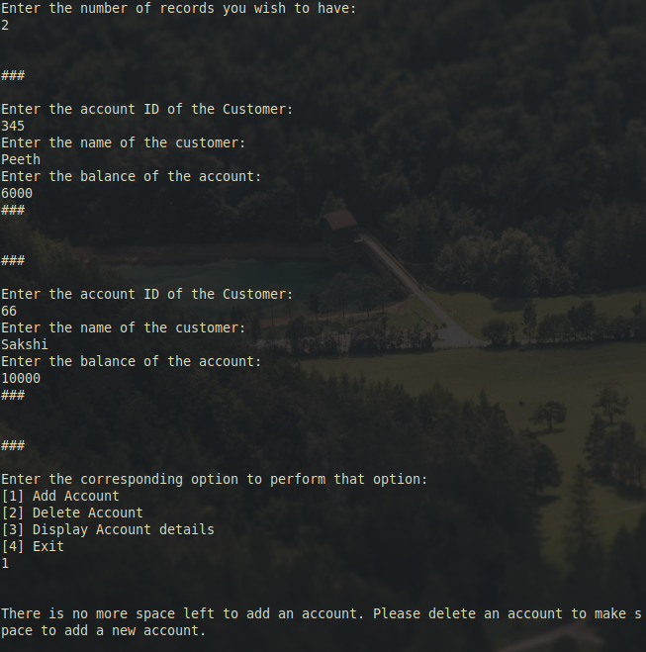
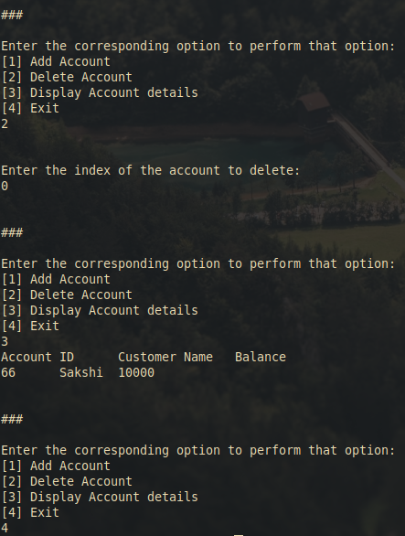
Conclusion:
This experiment teaches and displays the basics of arrays of objects and the utilizations of them.
Date: 26/09/2023 Signature of faculty in-charge

Post Lab Descriptive Questions

Q.1 If an array of objects is of size 10 and a data value have to be retrieved from 5th object then ________________ syntax should be used.
a)Array_Name[4].data_variable_name;
b)Data_Type Array_Name[4].data_variable_name;
c)Array_Name[4].data_variable_name.value;
d) Array_Name[4].data_variable_name(value);

Ans: a

Q.2)The Object array is created in _____________________
a)Heap memory
b) Stack memory
c) HDD
d) ROM
Ans: a

